22. Design DFA using simulator to accept odd number of a’s

**AIM:** To design DFA using simulator to accept odd number of a’s

**TRANSITION DIAGRAM:**

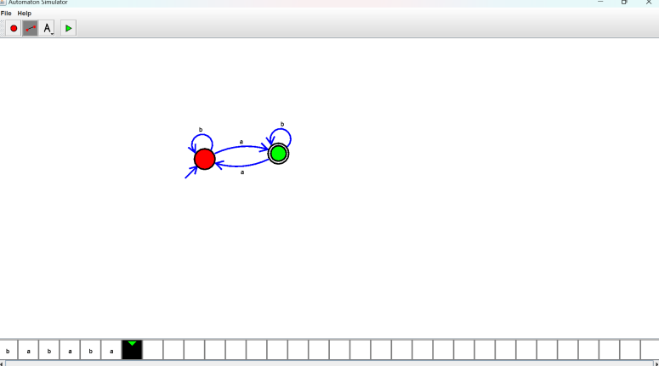

**RESULT**: Hence designed DFA using a simulator to accept the odd number of a’s by using a simulator